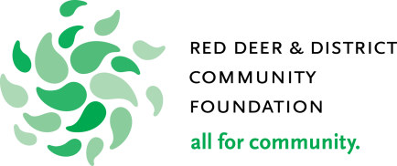

Red Deer Rotary Career Opportunity Award
Sponsored by: Rotary Club of Red Deer
Designated for: Red Deer Public School District
Red Deer Regional Catholic Schools

Application Process:
Submit the completed application to the Guidance Counsellors’ Office at your High School.

Deadline for applications is Monday, May 3, 2022 at 4:30 pm.

Your submission must contain the following:
- Completed application form
- Two signed, dated reference letters that include telephone numbers
- Transcript or outline of Grade 11 and 12 academic results
- Application essay
- Notice of Assessment from your parents most recent tax report. (If you cannot provide this please include a paragraph to explain why)
The following information is kept confidential.
Personal Information | Surname: | First Name:
Address: | City/Town: | Postal Code:
Date of Birth: | Phone Number: | Email:
Parent’s Name (1): | Parent’s Address: | Parent’s Occupation:
Parent’s Name (2): | Parent’s Address: | Parent’s Occupation:
Gross Annual Income of your family: (please refer to most recent Income Tax Returns as per Line 150) | Income: Year: | Grade 12 Semester Grade Average %:
How many people in your family?  Parents: _______  Siblings: _______ | What ages are your siblings: | Do you have any siblings presently attending post-secondary institutions? (please circle)  Yes No  If so, please list their name(s) and Institutions:
Which advanced education institution are you applying to attend? | What will be your program of study? | Expected length of program?
Please attach a separate page to respond to the following questions:

- What career are you seeking and why?
- Describe your financial plan (income and expenses) for the first year of your intended program of study. Some details to include are:
  - Do you plan to work while completing your secondary education?
  - Are there any savings you have access to?
  - Explain if there are any extenuating circumstances that lead to your financial need.
- Describe the other awards and scholarships you have applied for and intend to apply for this year.
- Describe your activities and involvement in these areas: Student Activities, Employment/Business, Community/Volunteer, Mentorship/Leadership, Artistic/Athletics, Family/Home.
- Describe your hobbies and interests.
- How have you demonstrated positive motivational and/or leadership skills?

I hereby apply for the Red Deer Rotary Career Opportunity Award for the year 2022. I certify all provided information is true, accurate and complete.

________________________________ ________________________________ Signature Date

Successful applications for 15 Rotary Career Opportunity Awards of $2,000/each will be announced before June 7, 2022.

